2018 RoboCup German Open: On the victory podium with igus
Cologne-based motion plastics specialist sponsors German robotics competition

They play football, master rescue operations and undertake the logistics in a smart factory: robots from 14 countries had competed against each other in April at the 2018 RoboCup German Open. The Carologistics team from Aachen became the German champion in the Logistics league – with support from the motion plastics specialist igus.

How far have robotics and artificial intelligence developed? Answers can be found in specialist journals, discussion forums or trade fairs. However, to experience the new systems from all around the world in live action is more exciting, as seen at the igus-sponsored 2018 RoboCup German Open in Magdeburg. Students and young engineers from around 40 colleges and research institutions had a wide range of robots in their baggage: from small humanoid robots up to table-high transport robots. They had to compete each other in various disciplines, for example in football, rescue operations or intralogistics tasks.

Student team from Aachen wins in the logistics league
Lubrication-free and maintenance-free high-performance plastics were used in a large number of such robots. This was also the case in the igus-sponsored Carologistics team, which topped the Logistics league. The robots from Aachen had to complete logistics tasks appropriate to a smart factory. The robots had to communicate with each other and find their way in an area covering 112 square metres without aid, transport rings and caps between assembly stations, and finally assemble the products. Teamwork par excellence. In the new intralogistics robots, the drylin linear modules were used in the three-axis control system of the gripper. In addition was an electric linear axis with a lead screw motor and a dryspin lead screw, which provided precision in pick and place. In the Standard league as well, where the robots had to face each other on the soccer field, igus supported the team B-Human of the University of Bremen and the German Research Centre for Artificial Intelligence. The previous year's winner came in 3rd place and like Carologistics, will face teams from all over the world in June at the World Championships in Montreal in Canada.

igus offers modular systems for cost-effective robots
The company igus has been a well-known name in the robotics sector for some time. Besides the equipping of industrial robots with plastic energy chains and highly flexible cables, the Cologne-based company has set the goal of enabling users a quick and cost-effective automation. The company igus introduced the robolink Apiro at the 2018 Hannover Messe. Gearboxes with linear motion and inverted and conventional robolink worm gears in four different sizes are planned and, thanks to the exceptional modularity, can be combined with each other as required. With the new modular system, therefore, even complicated movements and ideas can be implemented. The robolink ReBeL is also a novelty. The new concept is fundamentally different from the other robolink joints and enables robot manufacturers to generate new and very cost-effective solutions in the service robotics sector. Instead of stepper motors, brushless direct-current motors (BLDC motors) are used in the lightweight plastic strain wave gears.

PRESS CONTACT:  Lena Tan  Operations Director  Asean Region  igus® Singapore Pte Ltd.  84 Genting Lane  #06-03 Cityneon Design Centre  Singapore 349584  Phone: +65-64 87 14 11  Fax: +65-64 87 15 11  letan@igus.com.sg  www.igus.com.sg | ABOUT IGUS:  igus GmbH is a globally leading manufacturer of energy chain systems and polymer plain bearings. The Cologne-based family business has offices in 35 countries and employs 3.800 people around the world. In 2017, igus generated a turnover of 690 million euros with motion plastics, plastic components for moving applications. igus operates the largest test laboratories and factories in its sector to offer customers quick turnaround times on innovative products and solutions tailored to their needs.

The terms "igus", "chainflex", "CFRIP", "conprotect", "CTD", "drylin", "dry-tech", "dryspin", "easy chain", "e-chain", "e-chain systems", "e-ketten", "e-kettensysteme", "e-skin", "flizz", “ibow”, "iglide", "iglidur", "igubal", "manus", "motion plastics", "pikchain", "readychain", "readycable", "speedigus", "triflex", "twisterchain", "plastics for longer life", "robolink", and "xiros" are protected by trademark laws in the Federal Republic of Germany and internationally, where applicable.

Caption:

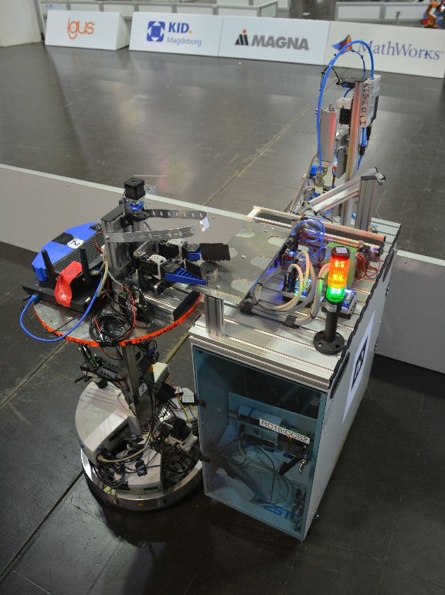
Picture PM3018-1
Intralogistics robots of the igus-supported Carologistics team at the 2018 RoboCup. (Source: igus GmbH)

