Corrugated hose 2.0: igus presents new ideas in energy supply

With the e-skin and e-shell, discover new options for flexible and affordable cable guiding

Hanover/Cologne, April 15, 2015 – In machinery and equipment construction, as well as in medical and automotive industries, corrugated hoses are an integral part of the energy supply system. At the Hannover Messe, the Cologne-based igus GmbH presents an entirely new idea: the e-skin. This easy-to-open hose can self-supporting contrast to comparable products, and can even be used in the clean room for short unsupported lengths. Existing corrugated hose systems can obtain a more defined movement with the new snap-on e-shell.

Corrugated hoses are used in a variety of applications, especially where the demands on the energy supply system are not particularly high. The advantage is that they are light, versatile and can guide energy, media and data at very low costs. With the e-skin and e-shell, igus shows at the Hannover Messe the development potential hidden in this product and how it makes moving energy even easier.

The e-skin: Compact design for unsupported lengths
The e-skin is a hose consisting of an upper and lower shell, which when clipped together is completely enclosed. Due to the simple and reusable opening mechanism, a trouble-free maintenance and inspection of cables is possible. igus also provides an additional tool with which the hose can be opened and closed quickly. In contrast to the conventional corrugated hose, the e-skin has a defined direction of movement and also can support itself. It can therefore be used for short unsupported lengths as a horizontal energy supply system. With its oval design the modular, expandable tube also offers more space than round corrugated hoses. Cables can be guided carefully using interior separation modules. Likewise, the e-skin can be tailored individually for each application by selecting different materials. The injection moulding process also allows for different colours, different even for the lower or upper part – and even for small quantities.
By virtue of the construction method and the high flexibility, the e-skin can be used in a variety of industries - from machine tools and medical technology through to sophisticated electronics manufacturing. Here, high speeds and accelerations are possible as they are required, for example, in pick-and-place applications. Because it is abrasion resistant, dust-proof and waterproof, it can also be used in clean room environments.

The e-shell: reinforcing existing system
In addition to the e-skin, igus offers a reinforcement for existing corrugated tube systems: the e-shell. The clip is easily attached to the normal corrugated hose, so that filling can be done at the top side of the joints of the corrugated hose. It is stabilised so that it can only move in one direction. Due to the guide elements on both sides, the corrugated hose has self supporting capability. If this solution is used for several corrugated hoses, they can be reliably guided side by side. Thanks to the defined minimum bending radius, the e-shell safely and reliably.protects the cables in the corrugated hose

PRESS CONTACT:  Oliver Cyrus  Head of PR and Advertising  igus® GmbH  Spicher Strasse 1a  51147 Cologne  Tel. 0 22 03 / 96 49-459  Fax +49 22 03 / 96 49-631  ocyrus@igus.de  www.igus.de/de/presse | ABOUT IGUS:  igus GmbH is a globally leading manufacturer of energy chain systems and polymer plain bearings. The Cologne-based family business has offices in 36 countries and employs around 2,700 people around the world. In 2014, igus generated a turnover of 469 million euros with motion plastics, plastic components for moving applications. igus operates the largest test laboratories and factories in its sector to offer customers quick turnaround times on innovative products and solutions tailored to their needs.

The terms ‘igus, e-ketten, e-kettensysteme, chainflex, readycable, easychain, e-chain, e-chainsystems, energy chain, energy chain system, flizz, readychain, robolink, pikchain, triflex, twisterchain, invis, drylin, iglidur, igubal, xiros, xirodur, plastics for longer life, CFRIP, dryspin, manus and vector’ are protected by trademark laws in the Federal Republic of Germany and internationally, where applicable.

Captions:

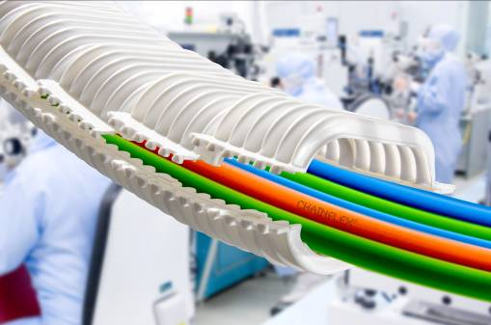
Image PM1615-1
e-skin can be used in the clean room for short unsupported lengths.
(Source: igus GmbH)

